The Plastic Necklace
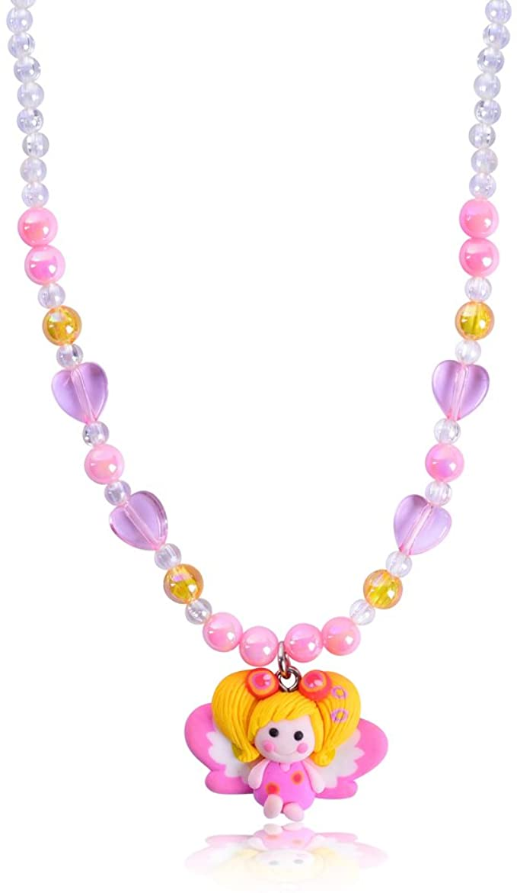

With the potential of Celestial Law being reinstated, I believe that the story of the little girl and her plastic necklace could be a teaching moment for all the children of light.
The story goes:
There was a young daughter who was given a plastic necklace when she was very young. And she loved that plastic necklace more than life itself. One night when her father came in to tuck the child into bed he kissed her and said, “I love you” to which the little girl replied, “I love you too, Daddy.” The father responded, “Well if you love me give me your plastic necklace.” The little girl looked shocked as she took in what her father was asking her, but after a moment, to recover she responded, “Oh no Daddy, that necklace was a gift from you, it is one of my most prized possessions!” To which the father hugged his daughter, kissed her lightly on the forehead, told her all is well and bid her goodnight. This process continued for many years with the father going in, telling his daughter that he loved her, the daughter saying she loved him, the father asking for the necklace and the daughter refusing. Some nights the daughter would offer her father her stuffed animals or other toys that she owned but all of which the father refused. This continued until one night, to the father’s surprise, when he entered the room he saw his daughter sitting at the edge of the bed with tears in her eyes. The father, quickly coming to her side and wrapping his arms around her, asked her what the matter was. To which the daughter gingerly placed the plastic necklace in her father’s hand and whimpered, “I love you Daddy, you can have my necklace.” The father now with tears in his own eyes, took the plastic necklace and put it in his pocket. But much to the daughter’s surprise, when her father’s hand returned to view, in it was a pearl necklace. “Daughter, I wanted to give you this pearl necklace, but I couldn’t give it to you while you were still clinging to childish things.”
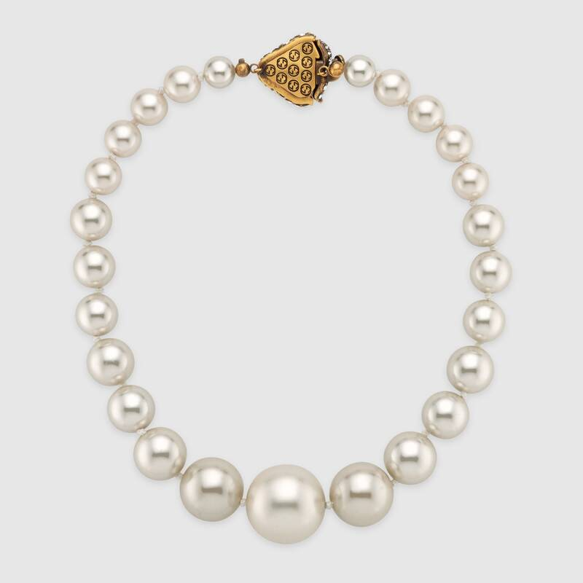
Much like the child with the plastic necklace, we hold on to things that we believe to have great value but are nothing more than children’s toys. When we are willing to lay all that we have on the altar, as did Abraham, the Father will produce, from behind His back, the pearl necklace that He has been wanting so desperately to give us.

I say this in the name of Jesus Christ, Amen.

